Task 0: Explain what you are doing/ going to accomplish

Create a receipt page that will display the total amount of food sold during the lunch time, and the price. Possibly a payment page, and finally an end of transaction success page.

Task 1: Sketch interface design

*Draft a rough design for the interface that allows the user to trigger functionality in task 1, while also annotating where the information in task 2 will be displayed. Create another sketch listing the interface widgets used to create the interface.*

It will just be a card with all the food sold and the price, and a credit card page, and a success page.

Task 2: Identify any classes required

*Explain what the class will represent, plus listing what information will be stored in the class and any functions the class will have.*

Canteen_content.food_sold

Canteen_content.food_cost

Canteen_content.food_cart

Task 3: Identify information to be displayed

*What information will the interface need to display to the user?*

How much of a food item had been sold, and the cost of all the prices added up. A few button to get to other pages.

Task 4: Identify user inputs

*What program functions can the user trigger through the interface?*

A submit button on the order page  
A continue button

Maybe a form?

And a back button

Task 5: Identify any constants or existing data if required

N/A

Task 6: Identify indexed data structures

Contents_list

Task 7: Determine what calculations are necessary

*Write out the calculations the program will have to compute.*

Plus and minus

Task 8: Develop a modular structure for your program

*Describe any functions that the computer program will have, identifying any sub-functions where required.*

Receipt – this will be the receipt page that shows everything that has been sold.

Pay – This could be a credit card page

Task 9: Define the functions identified

*Describe the functions for both the main program and any classes in terms of input and/or output where required. You may choose to do this with flow charts or pseudo-code (not Python code!). Add in additional steps or explanations using sequential, conditional, iterative statements where required. Identify global and/or local variables.*

AT ROUTE (‘/receipt’)

AT VIEW (‘receipt’)

PROGRAM plus_stock

SET data TO dict (contents_list EQUALS contents)

RETURN data

Task 10: Address any relevant implications such as usability, functionality, legal/ethical requirements.

The user should be able to click a button to get to the receipt page, from there, there will be a continue button or a back button to continue shopping. If the continue button is pressed it will take the user to a payment page, from there they click another button and it will take them to a success page and that will be the end of the transaction. I have used bright colours for the buttons as they pop out off the page. I have also labelled the functions accordingly and added more comments so if anything breaks and someone else tries to fix my code, they will understand it.

Task 11: Document test cases for testing the program

*Document any testing that can be used to test your program. If any input is inputted using the keyboard, describe the expected input, plus any exceptional, boundary or invalid cases.*

I have had a classmate test my website, they could find and easily use it. They said the buttons looked nice. However the note that says to click submit at the bottom of the page (order) wasn’t noticed easily. After they had found the note they clicked it and liked the receipt page, the way it was displayed, they then clicked continued and found the credit card page funny. They clicked continue from that page where they found themselves on the success page, they then clicked back to main and it took them back to main.

|  |  |  |  |
| --- | --- | --- | --- |
| **Test case** | **Expected Outcome** | **Actual Outcome** | **Fix** |
| Click the submit button | Goes to receipt page | Goes to receipt page | NONE |
| Total cost | Total cost | Broken | Created new variable total_cart and set to 0. Used a for loops and plused the canteen_content.food_cart |
| Total sold | Total sold | broken | Created new variable total_sold and set to 0. Used a for loops and plused the canteen_content.food_sold |
|  |  |  |  |

Task 12: Refine the plan

*Note any modifications here when iterating through the development cycles.*

I have made it so the user cannot stock up more than 100. I have done this by going to my html user_input page and adding max = “100” to the input tab

Task 13: Document testing

*Show screenshots of your program working with descriptions of each image. These images should test the tests cases listed above.*

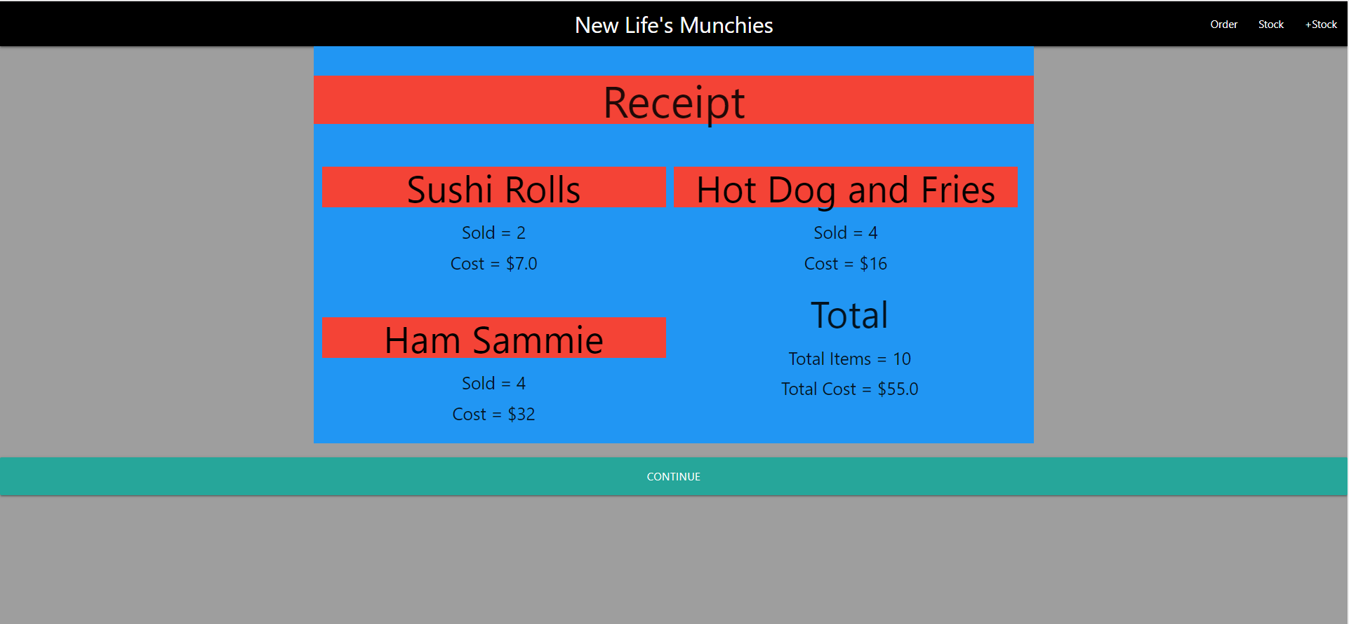

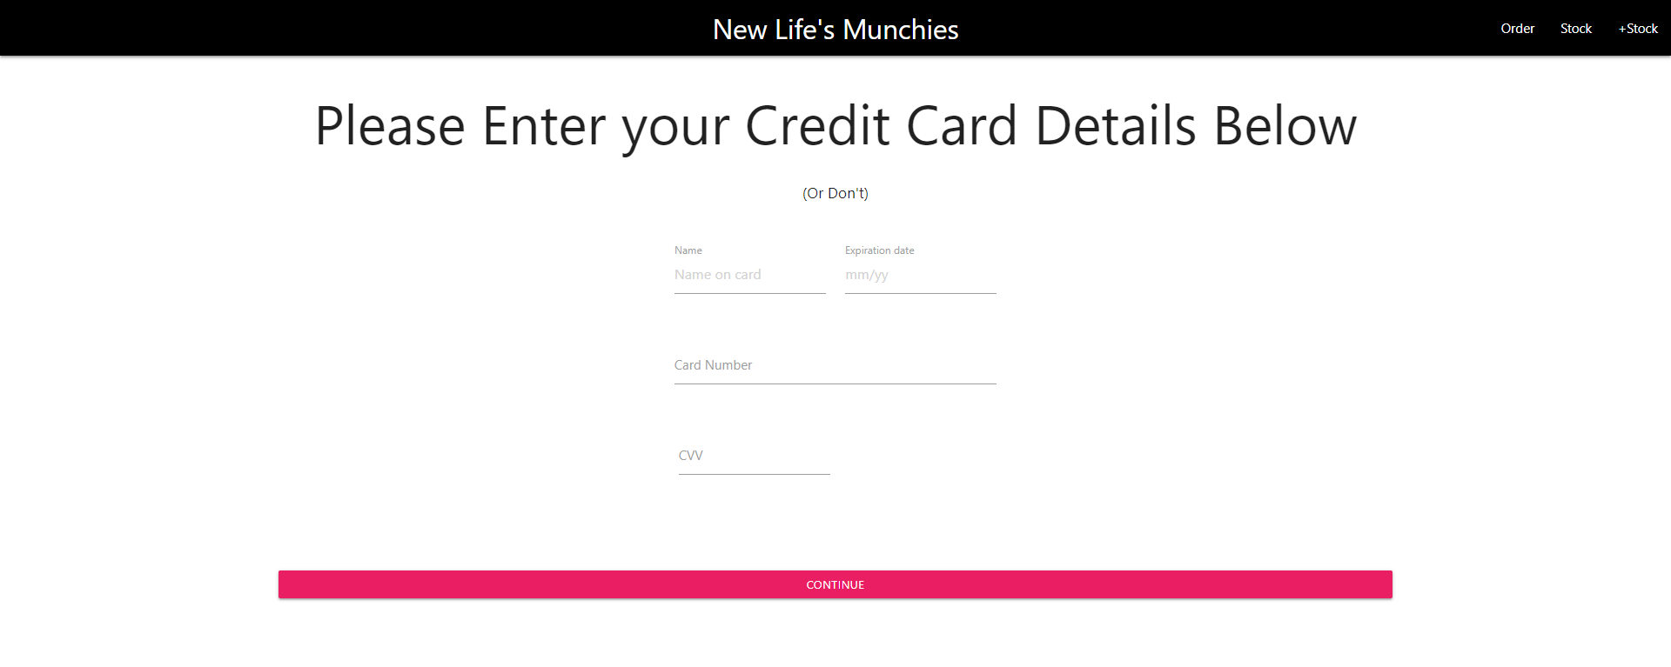

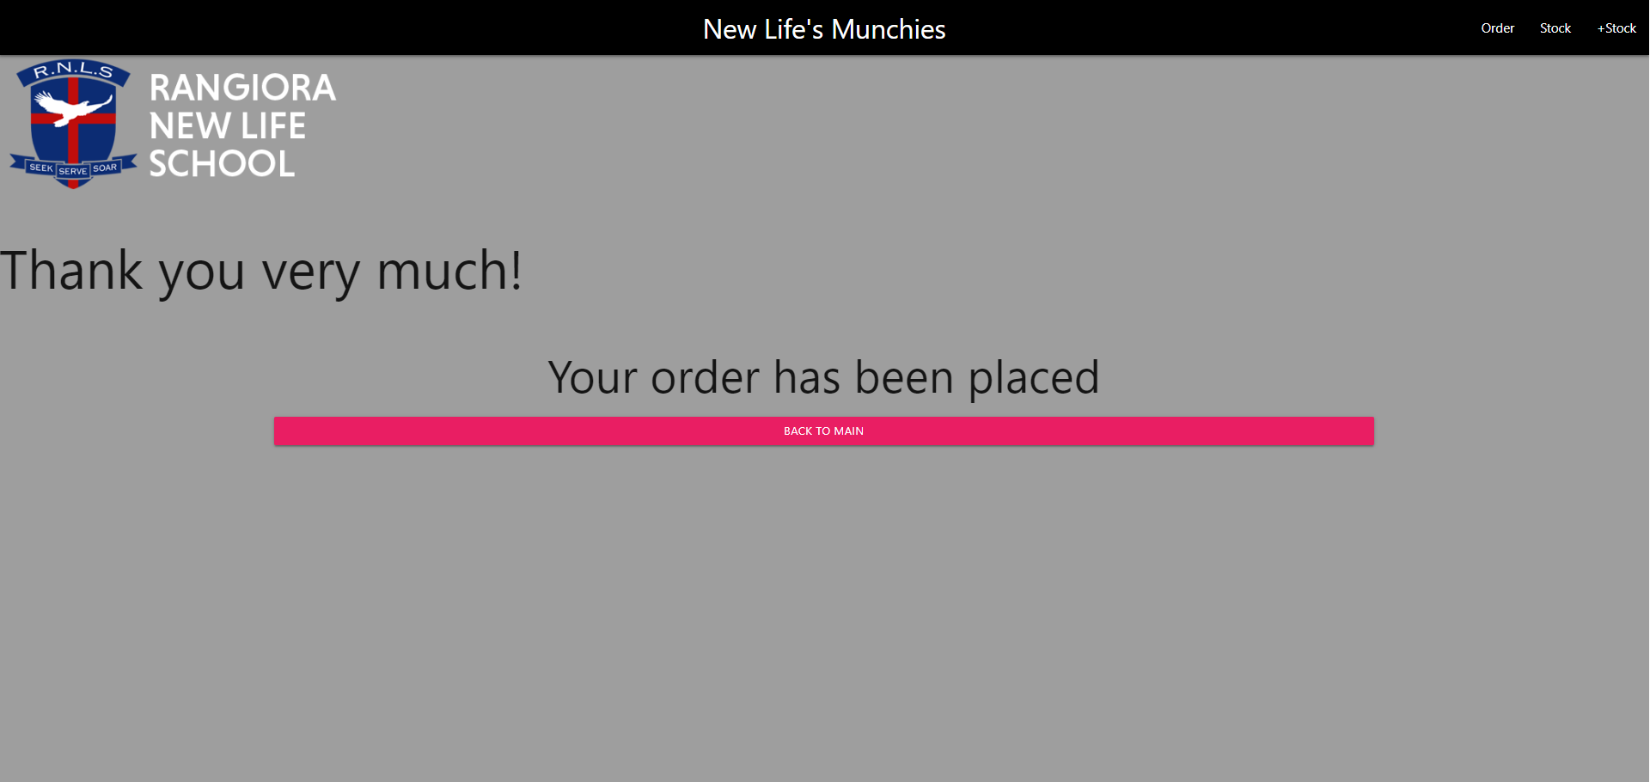

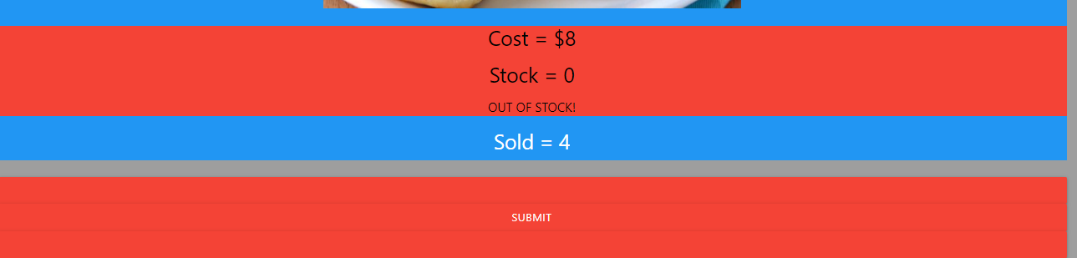

Task 14 : Evaluation

*How did your version turn out*

This version has turned out very well, and I like it. I had problems trying to get the total cost and total sold, however this was a very simple fix. I just needed to take a step back and think. I created a new variable and did python in html.

